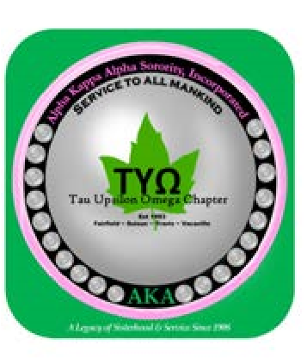

Alpha Kappa Alpha Sorority, Incorporated
®
T
AU
U
PSILON
O
MEGA
C
HAPTER

2022

B
IRTHDAY
&

A
NNIVERSARY
L
IST

January Birthdays | February  Birthdays | March Birthdays | April  Birthdays
2- Linda Bridges | 2-Natasha Michele Flint-Moore | 1-Deborah Cupid | 5- Gwendolyn Lawton
2- Sheila Flynn | 6- Shereene Wilkerson | 13-Carla Gregory | 6 – Denise Drummer-Taylor
3- Dominique Geoffroy | 12- Darcell Purefoy | 17-Alice Claiborne-Henry | 10- Andrea Valmore
11- Lynette P. Henley | 12- Shryl Avril | 19-Chelsea Bridges
14- Mary B. Russell | 18- Karen Dace | 23-LeeAnn Carradine
 | 25- Earline Murray
January  Anniversaries | February  Anniversaries | March  Anniversaries | April  Anniversaries
NONE | 17-Regina Thompson |  | 11- Doris Wilkerson
 |  |  | 20- Mary B. Russell
 |  |  | 24- Ria Rabun-Persinger
May  Birthdays | June  Birthdays | July  Birthdays | August Birthdays
9-Ria Rabun-Persinger | 5- Vicky Wesley | 1-Bertha Hamilton | 1-Paula D. Espejo
19-Yvonne Robbins | 14- Estella San Juan | 2-Jennifer Ritchie | 1- Tracee Johnson
24- Delphine Harris | 22- Melodie Whitney | 4-Jeann McDougald | 3- Jacquelyn King - Walton
28-Tiffany Carson |  | 5-Melba Thompkins | 23- Nadine Harris
30-Nanelle Jones-Sullivan |  | 13-Regina Thompson
 |  | 15-Yvonne Bullock
May  Anniversaries | June  Anniversaries | July  Anniversaries | August  Anniversaries
4- Linda Bridges | 11- E. Johnetta Wilson | 5-Teresa Travis | 18-Shereene Wilkerson
10- Yvonne Bullock |  | 7- Nanelle Jones-Sullivan
15- Shawnta’ Matthews |  | 25- Dominique Geoffroy
26-LeeAnn Carradine |  | 28-Tiffany Carson
September Birthdays | October Birthdays | November  Birthdays | December  Birthdays
20- Shawnta’ Matthews | 1- Michele Agee-Long | 2-Angela Vargas | 24-E. Johnetta Wilson
 |  | 9-Doris Wilkerson
 | 23-Cliffy Jones | 21-Teresa Travis
 |  | 24- Lavada Esters
 |  | 26- Leslie Brady
September  Anniversaries | October  Anniversaries | November  Anniversaries | December  Anniversaries
4-Michele Agee-Long | 10- Melodie Whitney | 11-Alice Claiborne-Henry | 30-Yvonne Robbins
14- Paula D. Espejo | 17-Bertha Hamilton

2021 TUO Birthday & Anniversary Calendar

LAST UPDATED 01.01.2021

